What is Caching in .NET?
Caching is a technique used to store frequently accessed data in memory so that future requests can be served faster without hitting the database or external service again.
Simple definition:
Caching = Save data temporarily → reuse it → improve performance

How Caching Works (Flow)
- User requests data (e.g., product list)
- App checks:
  - Is data in cache?
    - YES → return instantly
    - NO → fetch from DB
- Store fetched data in cache
- Next request → served from cache

Visual Understanding
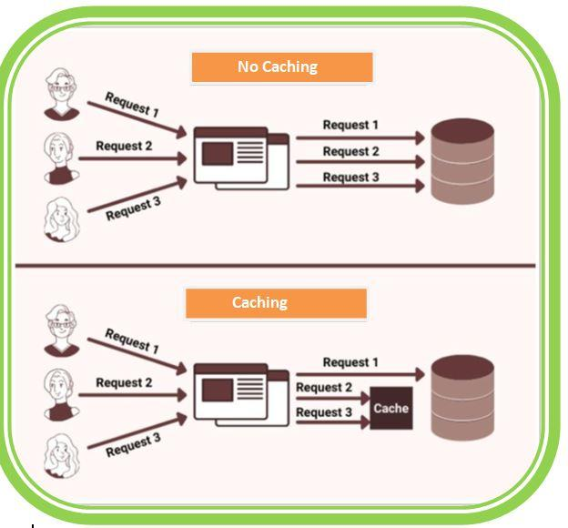
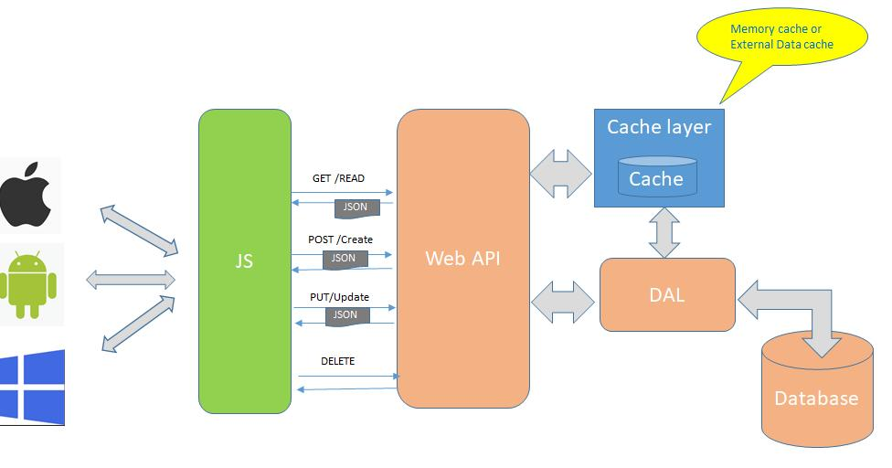
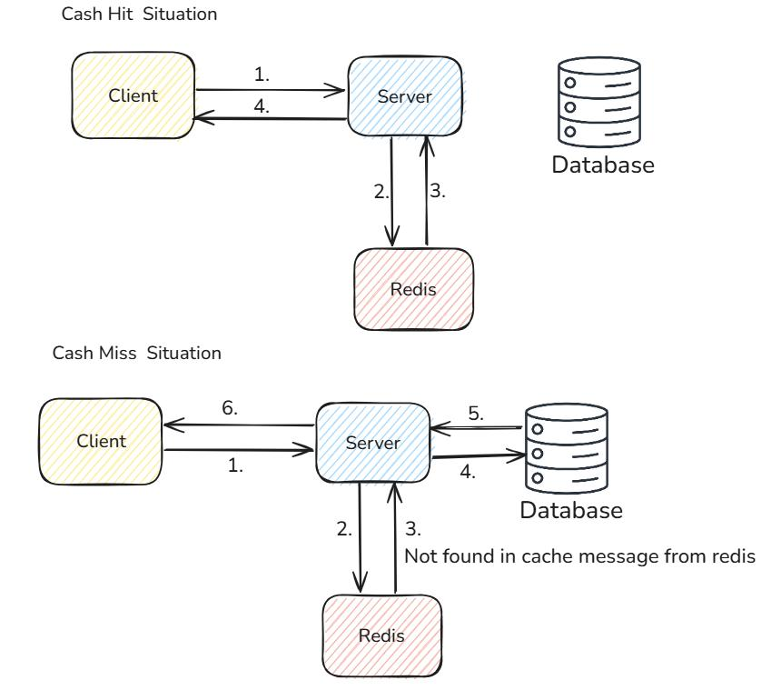
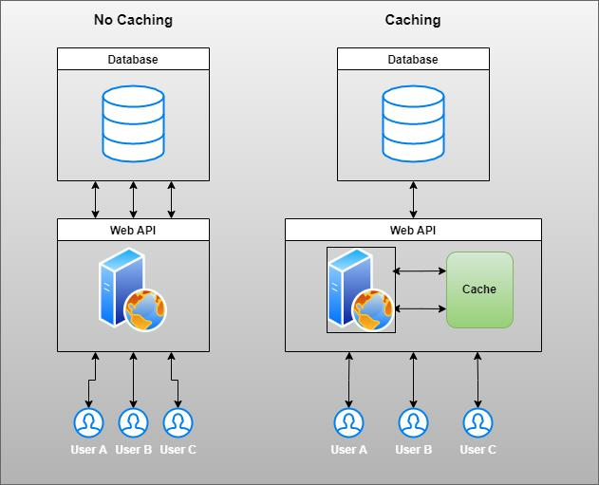
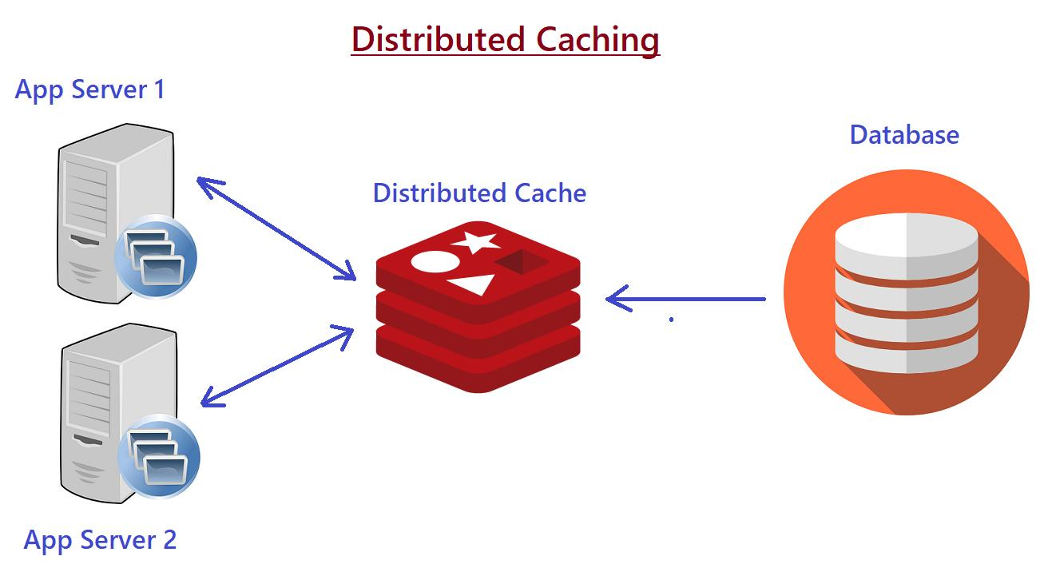
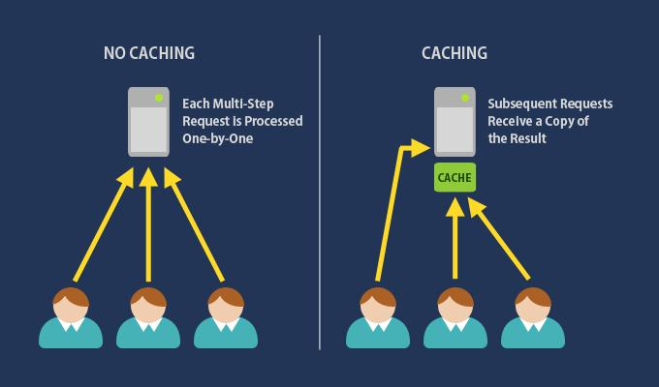

Types of Caching in .NET

1️ In-Memory Cache
- Stored in server RAM
- Fastest
- Used in single-server apps
Class: IMemoryCache

2️ Distributed Cache
- Stored in external systems like Redis
- Used in scalable apps
Example: Redis

3️ Response Caching
- Caches full HTTP response

Benefits of Caching
Benefit | Explanation
Performance | Faster response time
Reduced DB Load | Fewer database calls
Cost Saving | Less server usage
Scalability | Handles more users
Better UX | Faster app experience

Real-World Example (VERY IMPORTANT)

Case Study: E-Commerce Product API

Problem
- Product list API is slow
- Every request hits database
- High traffic causes DB overload

Solution: Use Caching
Cache product list for 5 minutes

Implementation in .NET 9

1️ Register Memory Cache
builder.Services.AddMemoryCache();

2️ Use in Controller
using Microsoft.AspNetCore.Mvc;
using Microsoft.Extensions.Caching.Memory;

[ApiController]
[Route("api/[controller]")]
public class ProductController : ControllerBase
{
private readonly IMemoryCache _cache;

public ProductController(IMemoryCache cache)
{
_cache = cache;
}

[HttpGet]
public IActionResult GetProducts()
{
string cacheKey = "productList";

// Check cache
if (!_cache.TryGetValue(cacheKey, out List<string> products))
{
// Simulate DB call
products = new List<string> { "Laptop", "Mobile", "Tablet" };

var cacheOptions = new MemoryCacheEntryOptions()
.SetAbsoluteExpiration(TimeSpan.FromMinutes(5));

_cache.Set(cacheKey, products, cacheOptions);
}

return Ok(products);
}
}

What Happens Internally

First Request
- Cache empty
- Fetch from DB
- Store in cache

Second Request
- Cache hit
- Return instantly

Real Output Behavior
Request | Time
1st | 500 ms (DB call)
2nd | 5 ms (Cache) ⚡

Important Concepts

Cache Expiration
- Absolute → expires after fixed time
- Sliding → resets time on each access

Cache Key
- Unique identifier
"productList"

Cache Invalidation
Remove/update cache when data changes
_cache.Remove("productList");

Interview Answer (Golden Line)
“Caching improves performance by storing frequently accessed data in memory, reducing database calls and improving response time.”

When NOT to Use Caching
Real-time data (like stock price)
Frequently changing data
Sensitive data

Next Level (If you want)
I can give you:
Distributed caching using Redis (real company use)
Caching with Web API + JWT project
Output caching in .NET 9
Interview questions + tricky scenarios
88888888888888888888888888888

Case Study: E-Commerce Product API (Caching + JWT)

Scenario
You are building a secure Product API where:
- Users must login → get JWT token 🔐
- Only authorized users can access product data
- Product list is heavy (comes from DB)
- High traffic causes performance issues

Problem Without Caching
- Every request → DB hit
- Slow response
- Server overload

Solution
Use In-Memory Caching (IMemoryCache)
- First request → fetch from DB
- Next requests → return from cache ⚡
- Secure using JWT

Architecture Flow
Client → JWT Auth → Controller → Cache
↓
(Miss) DB Call
↓
Store Cache

Step 1: Create Project
dotnet new webapi -n ProductApi

Step 2: Install Package
dotnet add package Microsoft.AspNetCore.Authentication.JwtBearer

Step 3: Configure JWT in Program.cs
using Microsoft.AspNetCore.Authentication.JwtBearer;
using Microsoft.IdentityModel.Tokens;
using System.Text;

var builder = WebApplication.CreateBuilder(args);

// JWT
builder.Services.AddAuthentication("Bearer")
.AddJwtBearer("Bearer", options =>
{
options.TokenValidationParameters = new TokenValidationParameters
{
ValidateIssuer = false,
ValidateAudience = false,
ValidateLifetime = true,
ValidateIssuerSigningKey = true,
IssuerSigningKey = new SymmetricSecurityKey(
Encoding.UTF8.GetBytes("SUPER_SECRET_KEY_123456789"))
};
});

builder.Services.AddAuthorization();

// Caching
builder.Services.AddMemoryCache();

builder.Services.AddControllers();
var app = builder.Build();

app.UseAuthentication();
app.UseAuthorization();

app.MapControllers();
app.Run();

Step 4: Create Auth Controller (JWT)
using Microsoft.AspNetCore.Mvc;
using Microsoft.IdentityModel.Tokens;
using System.IdentityModel.Tokens.Jwt;
using System.Security.Claims;
using System.Text;

[ApiController]
[Route("api/[controller]")]
public class AuthController : ControllerBase
{
[HttpPost("login")]
public IActionResult Login(string username, string password)
{
if (username != "admin" || password != "1234")
return Unauthorized();

var key = Encoding.UTF8.GetBytes("SUPER_SECRET_KEY_123456789");

var token = new JwtSecurityToken(
claims: new[] { new Claim(ClaimTypes.Name, username) },
expires: DateTime.UtcNow.AddMinutes(30),
signingCredentials: new SigningCredentials(
new SymmetricSecurityKey(key),
SecurityAlgorithms.HmacSha256)
);

return Ok(new { token = new JwtSecurityTokenHandler().WriteToken(token) });
}
}

Step 5: Product API with Caching + JWT
using Microsoft.AspNetCore.Authorization;
using Microsoft.AspNetCore.Mvc;
using Microsoft.Extensions.Caching.Memory;

[ApiController]
[Route("api/[controller]")]
[Authorize] // Protected API
public class ProductController : ControllerBase
{
private readonly IMemoryCache _cache;

public ProductController(IMemoryCache cache)
{
_cache = cache;
}

[HttpGet]
public IActionResult GetProducts()
{
string cacheKey = "product_list";

// Check Cache
if (!_cache.TryGetValue(cacheKey, out List<string> products))
{
// Simulate DB call
Thread.Sleep(3000); // simulate delay

products = new List<string>
{
"Laptop", "Mobile", "Tablet", "Headphones"
};

var options = new MemoryCacheEntryOptions()
.SetAbsoluteExpiration(TimeSpan.FromMinutes(5));

// Store in Cache
_cache.Set(cacheKey, products, options);
}

return Ok(products);
}
}

Step 6: How It Works (REAL FLOW)

Step 1: Login
POST /api/auth/login
Get JWT Token

Step 2: Call API
GET /api/product
Authorization: Bearer <token>

Behavior
Request | What Happens
1st | DB Call (3 sec delay)
2nd | Cache Hit (instant)

Real Output Scenario

First Request
Time: 3000 ms
Data from DB

Second Request
Time: 5 ms
Data from Cache

Important Concepts Used

JWT
- Secures API
- Only authenticated users can access

Caching
- Reduces DB calls
- Improves performance

Cache Expiration
.SetAbsoluteExpiration(TimeSpan.FromMinutes(5))

Cache Key
"product_list"

Real-World Improvements (VERY IMPORTANT)
In companies, you will also:
- Invalidate cache when product updates
_cache.Remove("product_list");
- Use Redis for distributed caching
- Add logging (Log4net / Serilog)
- Add DTO + AutoMapper

Interview Question From This
“How do you use caching with secured APIs?”
Answer:
First authenticate user using JWT, then use IMemoryCache or Redis to store frequently accessed data. On first request fetch from DB, store in cache, and return cached data for subsequent requests.

